[1]

An Efficient and Intelligent Decision Making for Eco-Fertilization

Ishita Katiyar1, Gaurav Sharma2, Sumukha Hegde3, Arpit Chakraborty4,

Manash Sarkar5

1,2,3,4,5 Atria Institute of Technology, Bengaluru, Karnataka, India

*1,2.3 ishitakatiyar11, gauravsharma01042000, sumuk911, achakraborty0410@gmail.com, 4   
5manash.sarkar26@gmail.com*

*Abstract*— ***Fertilizer use is typically under the limited control of farmers. For the farmers to achieve higher yields and reduce fertilizer loss, competent guidance is required for the best use of these fertilizers. Additionally, there is a connection between rainfall volume and nutrient loss for various fertilizer applications after each rainfall event. Rainfall that is moderate and falls at the right moment can help nutrients penetrate the soil's rooting zone and dissolve dry fertilizer. However, too much rain can increase the possibility of runoff and the pace at which nutrients like nitrogen (N) which is quintessential, phosphorus (P), and potassium (K) which are crucial, manganese (Mn), and boron (B) that are present in the soil. This research presents nutrient recommendations using an updated iteration of the random forest algorithm which is based on time-series data to forecast the required quantity of nutrients for various crops by examining rainfall patterns and crop fertility. The method suggested in this study, comes in handy for improving soil fertility by providing nutrients recommendations for optimum conditions for crop growth and reducing leaching and runoff potential.***

# INTRODUCTION

Agriculture plays a very important role in national economic growth. Agriculture contributes 17-18% to India's GDP and ranks second worldwide in farm outputs. Plants need fertilizers and fertilizers replace the nutrients which crops take from the top layer of the soil. The absence of fertilizers can cause a drastic reduction in the volume of crop output. But fertilization requires precise action. Rainfall patterns and the amount of nutrients needed for a certain crop must be considered when using fertilizers. Machine learning is the current technology that can solve this problem by using available data for crop fertility and rainfall. Farmers can greatly benefit from the support of robust information about crops. The proposed model also uses a machine-learning algorithm (random forest regression algorithm with k-fold cross-validation technique) and takes two inputs from the user that are crop and location. After applying the algorithm, the model predicts the amount of nutrients required along with the best time to use fertilizers. The website is built using Flask Python (web framework) to provide access on all platforms and can be shared among users.

# RELATED WORKS

A comprehensive study of the available literature presents a catalog of previous studies to address this issue. The authors show in [1] that predicting fertilizer usage can assist farmers to attain a proper yield with little waste by preventing toxicity and deficiency in plants to some extent. Paper [2] makes use of fuzzy logic systems that enable the reduction of fertilizer usage which results in an increase in crop productivity. Additionally, [10] shows that the enhanced efficiency of fertilizers is not sufficient for complications that can be caused by compaction. These issues can be prevented by improving the fertilizer recommendation which requires the establishment of a quantifiable relation under N and P for fertilizer usage, in terms of agricultural yield, nitrogen need, and nitrate remnant level which is shown in [11] and paper [4] seconds this by providing a comprehensive measure to estimate the weightage of nutrient requirements and also the role of the chemical properties of soil.

It is a difﬁcult task to predict crop yield due to stochastic rainfall patterns and also temperature variation. So we can apply different data mining techniques as propounded in [3] for crop yield prediction. Laura J.T. Hess *et al.* in [5] state that nitrogen leaching is prone in areas that have no-till management and this may cause crop loss. In [7] the authors suggest a novel metric for ‘soil health and quality’ including refinement of soil’s health.

The objective of the paper [8] is to examine the characteristic changes in the creation and elements of soil populaces and capabilities because of the collaboration between long haul treatment and precipitation variances, to decide if preparation history affects the water-obstruction of soil microorganisms. Also, Paper [13] predicts agricultural yield as a function of rainfall. This is accomplished by giving a general summary of how production is affected by rainfall and how much a given crop can yield given the amount of rainfall received. Because it examines all regression procedures, the suggested method of evaluation is superior to other existing methods of evaluation.

Potnuru Sai Nishant *et al.* in paper [6] predict the yield of practically all types of crops in India. This script makes innovative use of straightforward criteria such as state, district and area, allowing the user to forecast crop yields in any year. Paper [12] suggests the use of Transfer Learning techniques to create a pre-trained model for detecting patterns in the dataset, which we then used to predict crop yields. In [14], supervised algorithms that boost crop yields, reduce human labor, time, and energy exerted on various agricultural tasks, and plant suggestions based on particular soil parameters are used to produce a complete way to predict crop sustainability. The study [16] demonstrated the capabilities of a machine learning model that can interpret and evaluate results, can be utilized to create the most useful information in long-term fertilizer studies, and that these techniques can be employed in other long-term experiments. Paper [17] develops an interesting decision-based system on climatic, crop, and insecticide/pesticide data. This is done

Senthil Kumar Swami Durai *et al.* in [18] propose an integrated solution to Pre-Cultivation activities. The goal of this study is to assist a small farm in becoming more efficient and achieving a high production at a low cost. It also aids in the estimation of total growth expenses. It will assist one in planning forward. Pre-cultivation activities lead to an integrated solution in agriculture. M.S. Suchithra and Maya L. Pai propose solutions to soil nutrient classification problems utilizing the rapid learning classification technique called an Extreme Learning Machine (ELM) with various activation functions in [19].

Crop diseases are one of the primary causes that impact the overall yield. Paper [15] conducts this study using an IoT system in the Kashmir Valley, it proposes an apple disease prediction model using data analysis and machine learning. The challenges of incorporating new technology into traditional agricultural practices are discussed in this paper.

# PROPOSED MODEL

In this study, a predictive model for the nutrients required for crops was obtained using random forest. Random forest regression with the k-fold cross-validation technique represents the model and the model with acceptable accuracy for the prediction is then obtained. A total of seven features have been used to evaluate the algorithm.

As shown in Fig 3.1, the algorithm requires input from the user (such as location and crop). The location is fed to the Weather API which will return certain characteristics (e.g. temperature, humidity, rainfall) and if there is a possibility of heavy rainfall, a precautionary message is displayed to the user, otherwise, the proposed algorithm is followed.

### **Random Forest Algorithm**

Random forest (RF) is a collection of multiple decision trees that have variable hyper-parameters and are trained using varying subsets of data. In our project, we are going to take crop and location as input, and based on it, we will predict the value of N, P, and K. First, we will divide our dataset into the training and the test datasets, where training dataset is 80% of the original data and the rest 20% is test data. Then we will create three different random forests of size 50 (decision tree) for each N, P, and K and outputs the mean of the classes as the prediction of all the trees.

### **Input Features**

* **Crop: *rice, cotton, mango, orange, lentil, etc.***
* **Temperature: *temperature measured in Celsius***
* **Humidity: *measured relatively in percentages***
* **Rainfall:** ***rainfall in mm***

***Output Features***

* **Label N:  *proportion of Nitrogen content in the soil***
* **Label P: *proportion of Phosphorous content in the soil***
* **Label K: *proportion of Potassium content in the soil***

### **Data Preparation**

Crop Recommendation Dataset [20]

Last access date: 16.11.2021

Actual dataset contains eight features. All of the features are not useful for the proposed model. Therefore, a dimension reduction technique called feature selection is applied and seven features, then selected for evaluation.

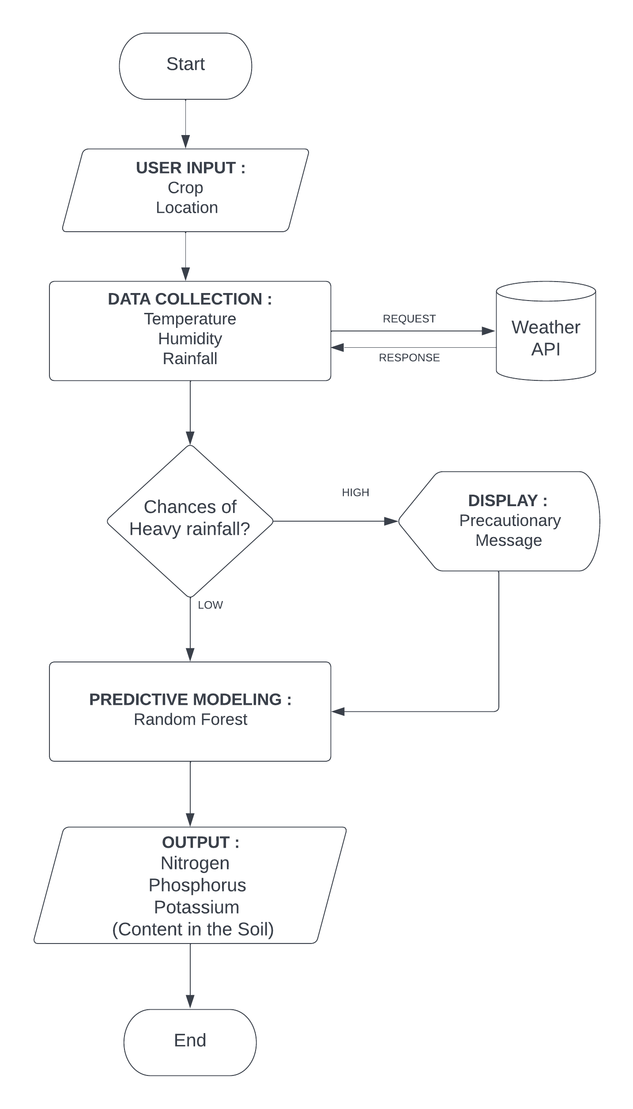

Fig 1: Project Flow

|  |
| --- |
| **BEGIN:** |
| **Step 1**: The dataset of size n=2200 is divided into training and test dataset (where the raining set is 80% and the test set is 20% that is training set=1,760 and the test set=240). |
| **Step 2**: Apply random forest regression to each N, P and K (Nitrogen, Phosphorus & Potassium) value with n estimators=50 (n estimators is the number of decision trees). |
| **Step 3**: Train the N label, P Label and K Label with the training dataset and dependent variable (Where the dependent variable is N for N Label, P for P Label and K for K Label). |
| **Step 4**: Each N Label, P Label and K Label generates a 50 decision tree as an output based on the training dataset. |
| **END** |

Random Forest Algorithm

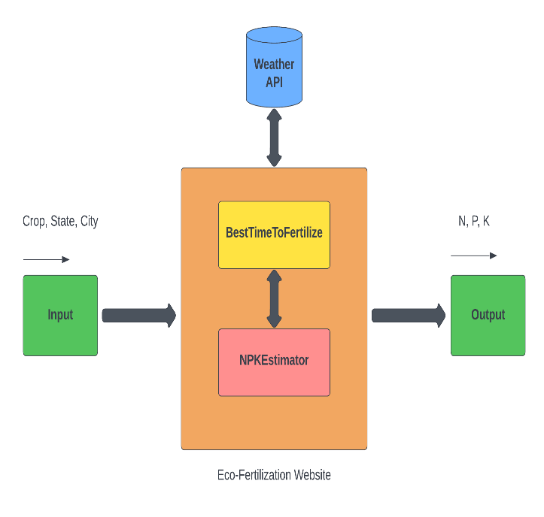

Fig 2: Block Diagram

# CONCLUSION

This research aims to provide an intelligent and optimistic decision for the farm system to optimize fertilizer usage.

# References

[1] Krutika Hampannavar, Vijay Bhajantri, Shashikumar G. Totad “Prediction of Crop Fertilizer Consumption,” Fourth International Conference on Computing Communication Control and Automation (ICCUBEA),2018, PP.1-5

[2] G. Prabakaran, D. Vaithiyanathan, Madhavi Ganesa, “Fuzzy decision support system for improving the crop productivity and efficient use of fertilizers,” Computers and Electronics in Agriculture, vol-150, 2018, PP. 88-97

[3] Shital Bhojani, Nirav Bhatt, “Data Mining Techniques for Crop Yield Prediction,” Computers and Electronics in Agriculture, vol-6, 2018, PP. 357-358

[4] Yulong Yin, Hao Ying, Huifang Zhen, Q ingsong Zhang, Y anfang Xue, Zhenling I, “Estimation of NPK requirements for rice production in diverse Chinese environments under optimal fertilization rate,” Agricultural and Forest Meteorology, vol-279, 2019, PP. 1-6

[5] Laura J.T. Hess, Eve-Lyn S. Hinckley, G. Philip Robertson, Pamela A. Matson, “Rainfall intensification increases nitrate leaching from tilled but not no-till cropping systems in the U.S. Midwest,” Agriculture, Ecosystems & Environment, vol-290, 2020, PP. 1-10

[6] Potnuru Sai Nishant,Pinapa Sai Venkat,Bollu Lakshmi Avinash,B. Jabber, “Crop Yield Prediction Based on Indian Agriculture using Machine Learning,” 2020 International Conference for Emerging Technology (INCET), 2020, PP. 1-4

[7] Tony Yang, Kadambot H.M., Siddique, Kui Liu, “Cropping systems in agriculture and their impact on soil health,” Global Ecology and Conservation, vol-23, year, PP. 1-13

[8] János Kátai, Ágnes Oláh Zsuposné, Magdolna Tállai, Tarek Alshaal, “Would fertilization history render the soil microbial communities and their activities more resistant to rainfall fluctuations? ,” Ecotoxicology and Environmental Safety, vol-201, 2020, PP. 1-11

[9] Usman Ahmed, Jerry Chun-Wei Lin, Gautam Srivastava, Youcef Djenouri, “A nutrient recommendation system for soil fertilization based on Evolutionary Computation,” Computers and Electronics in Agriculture, vol-189, 2021, PP. 1-7

[10] A.Hussein, Diogenes L. Antille, Shreevatsa Kodur, GuangnanChen, Jeff N.Tullberg, “Controlled traffic farming effects on productivity of grain sorghum, rainfall and fertilizer nitrogen use efficiency,” Journal of Agriculture and Food Research, vol-3, 2021, PP. 1-17

[11] Zujiao Shi, Donghua Liu, Miao Liu, Muhammad Bilal Hafeez, Pengfei Wen, Xiaoli Wang, Rui Wang, Xudong Zhang, Jun Li, “Optimized fertilizer recommendation method for nitrate residue control in a wheat–maize double cropping system in dryland farming,” Field Crops Research, vol-271, 2021, PP. 1-10

[12] Janmejay Pant, R.P. Pant, Manoj Kumar Singh, Devesh Pratap Singh, Himanshu Pant, “Analysis of agricultural crop yield prediction using statistical techniques of machine learning,” Materials Today: Proceedings, vol-46, 2021, PP. 1-10

[13] Benny Antony, “Prediction of the production of crops with respect to rainfall.,” Environmental Research, vol-202, 2021, PP. 1-5

[14] Akash Manish Lad, K. Mani Bharathi, B. Akash Saravanan, R. Karthik, “Factors affecting agriculture and estimation of crop yield using supervised learning algorithms,” Materials Today: Proceedings, 2022, PP. 1-10

[15] Raves Akhtar, Shabbir Ahmad Sofi, “Precision agriculture using IoT data analytics and machine learning,” Journal of King Saud University - Computer and Information Sciences, 2021, PP. 1-17

[16] Saheed Garnaik, Prasanna Kumar Samant, Mitali Mandal, Tushar Ranjan Mohanty, Sanat Kumar Dwibedi, Ranjan Kumar Patra, Kiran Kumar Mohapatra, R.H. Wanjari, Debadatta Sethi, Dipaka Ranjan Sena, Tek Bahadur Sapkota, Jagmohan Nayak, Sridhar Patra, Chiter Mal Parihar, Hari Sankar Nayak, “Untangling the effect of soil quality on rice productivity under a 16-years long-term fertilizer experiment using conditional random forest,” Computers and Electronics in Agriculture, vol-197,2022, PP. 1-10

[17] Rubby Aworka, Lontsi Saadio Cedric, Wilfried Yves Hamilton Adoni, Jérémie Thouakesseh Zoueu, Franck Kalala Mutombo, Charles Lebon Mberi Kimpolo, Tarik Nahhal, Moez Krichen, “Agricultural decision system based on advanced machine learning models for yield prediction: Case of East African countries,” Smart Agricultural Technology, vol-3, 2022, PP. 1-9

[18] Senthil Kumar Swami Durai, Mary Divya Shamili, “Smart farming using Machine Learning and Deep Learning techniques,” Decision Analytics Journal, vol-2, 2022, PP. 1-30

[19] M.S. Suchithra, Maya L. Pai, “Improving the prediction accuracy of soil nutrient classification by optimizing extreme learning machine parameters,” Information Processing in Agriculture, vol-7, 2022, PP. 1-11

[20] Kaggle, “ <https://www.kaggle.com/datasets/atharvaingle/crop-recommendation-dataset> ” (accessed on 16th November 2021)

1.